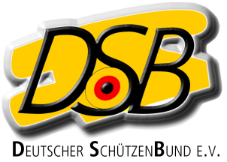

Declaration
for EU foreigners without ID of an
International Federation (ISSF, WA, IPC)
for the Bundesliga-Season 2023/24

Herewith the athlete /

Name, given name

Club

Date of birth

Nation

Discipline

declares that from 01/01/2023 to 12/31/2024 he / she will not take part in the highest national individual championship as well as foreign competitions of his/her home country or a third country in the above mentioned discipline.

He / she will be treated equal as a German athlete

..
Place, date Signature

