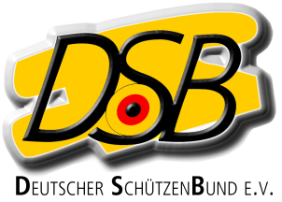

Declaration
for EU foreigners without ID of an
International Federation (ISSF, WA, IPC)
for the Bundesliga-Season 2022/23

Herewith the athlete

Name, given name

Club

Date of birth

Nation

Discipline

declares that he / she will not take part at national and international competitions of his / her home country in the above mentioned discipline between the 01.01.2022 and the 31.12.2023

He / she will be treated equal as a German athlete

..
Place, date Signature

