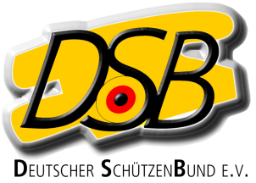

Declaration
for foreign athletes of the EU without ID-number of an
International Federation (ISSF, WA, IPC)
for the Bundesliga-Season 2018/2019

Herewith the athlete

Name, Surename

Date of birth

Nation

Discipline

declares that he / she will not take part at national team competitions and international competitions of his / her home country in the above mentioned discipline between the 01.04.18 and the 31.03.2019

He / she will be treated equal as a German athlete

..
Place, date Signature

