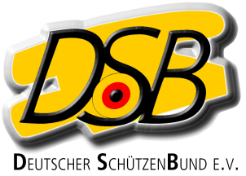

Declaration
for foreign athletes of the EU without ID-number of an
International Federation (ISSF, WA, IPC)
for the Bundesliga-Season 2016/2017

Herewith the athlete

Name, Surename

Date of birth

Nation

Discipline

declares that he / she will not take part at national and international competitions of his / her home country in the above mentioned discipline between the 01.03.16 and the 29.02.2017

He / she will be treated equal as a German athlete

..
Place, date Signature

